The Valdosta Preservation Awards recognize significant contributions to the preservation and enhancement of historic buildings in the Valdosta Historic District. Projects completed within the last three (3) years are eligible for an Award. Nominations are reviewed by the Valdosta Preservation Awards Committee, comprised of members of the Valdosta Historic Preservation Commission, Lowndes County Historical Society, and the Valdosta Heritage Foundation.

Outstanding Achievement Award | This award recognizes exemplary accomplishments in historic building rehabilitation or restoration. Awards in this category are given for complex or large-scale projects. Successful projects in this category will:  - Preserve the exterior historic integrity of a building by retaining a building’s significant portions and features through repairs and sensitive alterations (including compatible additions), while making possible an efficient contemporary use; AND/OR  - Restore a building’s exterior to its original appearance based on historical or physical evidence (authentic interior rehabilitation or restoration is not necessary but could weigh heavily in decisions to give this award).
Distinguished Merit Award | This award recognizes preservation improvements made to historic buildings that contribute to Valdosta’s heritage. Awards in this category are given for simpler, smaller scale projects, and do not require extensive restoration or rehabilitation work.
Stewardship Award | This award recognizes property owners for their long-term care, maintenance, stabilization, or protection of a contributing historic building.
Excellence in Compatible  New Construction Award | This award recognizes excellence in the design of new construction that complements and reflects the architectural character of the Valdosta Historic District.
Harold M. Bennett  Lifetime Achievement Award | This exceptional award recognizes a person from our community who has dedicated many years of his or her life to historic preservation and impacted preservation efforts in the City of Valdosta. This person has had significant and sustained accomplishments related to the preservation of our community’s architectural and cultural heritage, which may include: the restoration of historic buildings; the designation of historic properties; leadership or significant contribution to a community-based preservation organization; a sustained record of leadership of, or contributions to, historic preservation; or a significant accomplishment that advances the preservation ethic within our community.

Deadline: Friday, April 21, 2023 Only completed nominations, submitted/postmarked by the deadline, will be considered. Awards are competitive and only one award will be given per category. Decisions of the Awards Committee will be based on the contributions of the project to the architectural and historical character of the Valdosta Historic District. The project’s compliance with the Valdosta Historic District Design Guidelines and the Secretary of the Interior’s Standards for Treatment of Historic Properties will also be considered. See the following page for complete nomination requirements. For more information or to download a nomination form, please visit: www.valdostacity.com/planning
Please direct any questions to: Jeff Brammer (229) 259-3563 or jbrammer@valdostacity.com
Valdosta Historic Preservation Commission

Project Eligibility Requirements (does not apply to Stewardship Award Nominations):
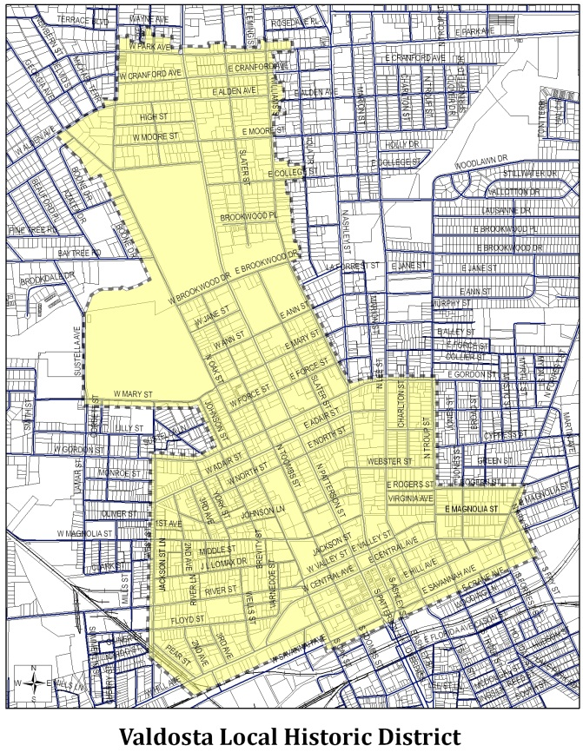
- Project must be within the Valdosta Historic District.
- Project must be completely finished. Only projects completed within the past three (3) years are eligible.
- Projects must be in compliance with the Valdosta Historic District Design Guidelines.
- Projects nominated for the Outstanding Achievement Award and Distinguished Merit Award must be 50 years old or older and listed as a contributing building within the Valdosta Historic District. To find out the contributing status of your building, please contact Jeff Brammer at (229) 259-3563 or jbrammer@valdostacity.com.

Lifetime Achievement Eligibility Requirement

- The nominee is not required to reside within the Valdosta Local Historic District.

Nomination Requirements

- Completed nomination form. Please type or print clearly in pen.

- Brief project description, limited to no more than one (1) page. If nominating a building, include information on the building’s history, architectural style, date of construction, details about the rehabilitation and/or restoration work, and the names of architects, contractors, or other design professionals involved in the project. Also list any grants or tax incentives used to help make the project possible. If nominating a person or group for the Lifetime Achievement, the award nomination should include an overview of all the nominee has accomplished in the field of historic preservation, with specific examples of their contribution to preserving Valdosta’s history. Stewardship nominations should include a description of the preserved resource as well as some information on the person or group who has preserved the resource.

- At least two (2) color photographs of the project. Photographs must be submitted with the nomination form. If using digital photography, images should be in .jpg format, have a resolution of 300 dpi, and should be burned to a CD and submitted with the nomination form, or emailed along with the nomination form. Ideally, nominations should include two (2) “before” photos of the project, two (2) “after” photos of the project, one (1) historic image, two (2) close-ups of architectural details, and two (2) photos of the interior.

Nomination materials may be submitted in hard copy or electronically.
Nominators and award winners will be notified the second week of May 2023.
Awards will be formally presented at the City Council meeting on Thursday, May 25, 2023.
Category of Award Nomination

Outstanding Achievement Stewardship
Distinguished Merit Excellence in New Construction
Lifetime Achievement

Building, Person, Project or Group Being Nominated:

If a building, the date Project Began: Date Project Completed:

Building, Person, Project or Group information:
Name Phone
Address Email
City State Zip Code

If a Building or Project, Owner’s Information:
Name (if applicable) Phone
Address Email
City State Zip Code

Person Submitting this Nomination:
Name Phone
Address Email
City State Zip Code

Please remember to submit at least two (2) color photographs of the building and a one-page description of the building rehabilitation or person/group being nominated (see Nomination Requirements) with this nomination form. Incomplete nominations will not be accepted.

Submit your Nomination Form and Supporting Materials

Mail Nominations To: | OR | Email Nominations To:
Valdosta Preservation Awards |  | Jeff Brammer
Planning & Zoning Division |  | Historic Preservation Planner
P.O. Box 1125 |  | jbrammer@valdostacity.com
Valdosta, GA 31603-1125

Project Description:

