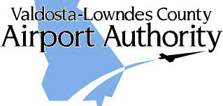

AGENDA

DATE: Wed, July 15, 2020
TIME: 8:00 A.M.
PLACE: Valdosta-Lowndes County Parks and Recreation Authority 1901 N. Forrest St
AGENDA:
1. CALL TO ORDER
2. REVIEW MINUTES – June 2020
3. PROJECT REVIEW
- AIP-34 Property Acquisition Services
- AIP-35 N Taxi Lanes, Twy M, Drainage Design
- AIP-36 Rwy 35 RPZ Property Acquisition
- TIA ATCT
- AIP-38
4. Delta
- Ticket Price Comparison
- Enplanements
5. AIRPORT MANAGER’S REPORT
6. OLD/NEW BUSINESS
- Hangar/Building availability
- General Aviation Terminal/SPLOST VIII
- August Meeting Date
- Holt Comments
7. CITIZENS TO BE HEARD
8. NEXT MEETING: August 1X, 2020

