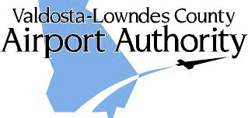

AGENDA

DATE: Mon, June 10, 2019
TIME: 8:00 A.M.
PLACE: Airport Conference Room
AGENDA:
1. CALL TO ORDER-Pledge of Allegiance
1a. Election of Airport Authority Chairman
1b. Election of Airport Authority Vice Chairman
2. REVIEW MINUTES – May 2019
3. PROJECT REVIEW
- AIP-33
- AIP-34 Design Projects and PAPIs
4. Delta
- Ticket Price Comparison
- Enplanements
5. AIRPORT MANAGER’S REPORT
6. OLD/NEW BUSINESS
- Hangar/Building availability
- Land contiguous to the airport
- Public Safety Officer Concept
- Holt Comments
7. CITIZENS TO BE HEARD
8. NEXT MEETING: Wednesday, July 10, 2019

