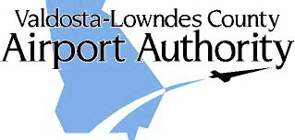

AGENDA

DATE: Wed, May 13, 2020
TIME: 8:00 A.M.
PLACE: Zoom Meeting https://us02web.zoom.us/j/8809012884
Call 605-472-5294 access code 432626 with problems
AGENDA:
1. CALL TO ORDER
2. REVIEW MINUTES – April 2020
3. PROJECT REVIEW
- AIP-34 Property Acquisition Services
- AIP-35 N Taxi Lanes, Twy M, Drainage Design
- AIP-36 Rwy 35 RPZ Property Acquisition
- TIA ATCT
- AIP-38 CARES Act
4. Delta
- Ticket Price Comparison
- Enplanements
5. AIRPORT MANAGER’S REPORT
6. OLD/NEW BUSINESS
- Hangar/Building availability
- General Aviation Terminal/SPLOST VIII
- Holt Comments
7. CITIZENS TO BE HEARD
8. NEXT MEETING: Wednesday, June 10, 2020

