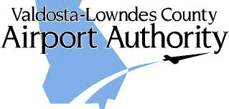

AGENDA

DATE: Wed, September 11, 2019
TIME: 8:00 A.M.
PLACE: Airport Conference Room
AGENDA:
1. CALL TO ORDER-Pledge of Allegiance
2. REVIEW MINUTES – August 2019
3. PROJECT REVIEW
- AIP-33
- AIP-34 Design Projects and PAPIs
- AIP-35
- AIP-36
- TIA ATCT
4. Delta
- Ticket Price Comparison
- Enplanements
5. AIRPORT MANAGER’S REPORT
6. OLD/NEW BUSINESS
- Hangar/Building availability
- Land contiguous to the airport
- Holt Comments
7. CITIZENS TO BE HEARD
8. NEXT MEETING: Wednesday, October 9, 2019

