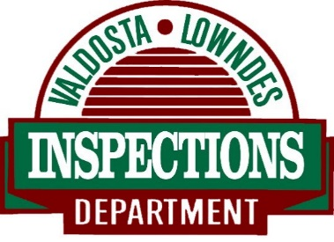

Inspections Department
DEMO STATEMENT

Project Location: ______________________________________________ Map _______ Parcel ______
I understand that I am responsible for the retirement of gas, electric, and water services from the demolition site prior to the commencement of any demolition work.

OVERVIEW OF ASBESTOS REGULATIONS

General: Any building that is to be demolished or renovated where structural members are removed, or burned as a practice burn by fire departments (hereinafter called “activity”) must adhere to the following procedures:
- Prior to the beginning of any activity on the building, it must be determined if any asbestos containing material is present. This shall be conducted by a Georgia Licensed Asbestos Inspector.
- If asbestos containing materials are discovered as a result of the inspection, they must be removed by a Georgia Licensed Asbestos Contractor, prior to the activity.
- Whether asbestos is found or not, there is a 10 working day period notification requirement to the Georgia EPD for these activities. This must be done on the correct form and submitted by mail to the EPD.
Contact Information: EPD Asbestos Program, Atlanta, GA (404) 363-7026
EPD Asbestos Program, Brunswick, GA (912) 264-7284
https://epd.georgia.gov/

The permit holder or authorized agent is responsible for calling for all required inspections after the demolition is complete.

Contractor/Owner: _______________________________________ Date: _________________________

