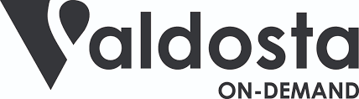

Public Participation Plan

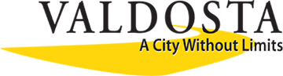
Valdosta On-Demand
Public Participation Plan

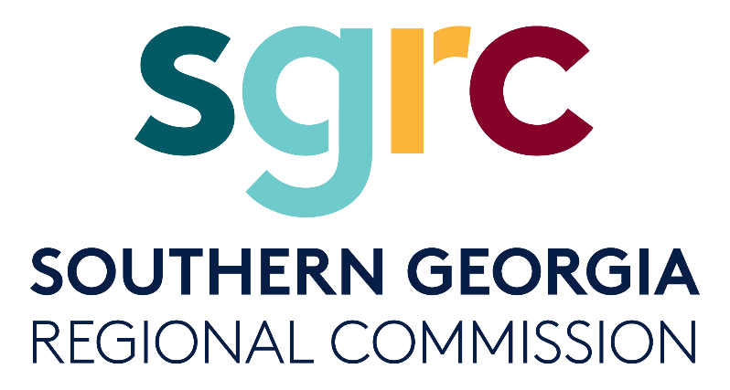
Adopted: Date TBD

1937 Carlton Adams Drive
Valdosta, Georgia 31601
229-333-5277
1725 South Georgia Parkway West
Waycross, Georgia 31503
912-285-6097
www.sgrc.us
The contents in this publication reflect the views of the author(s), who is (are) responsible for the facts and accuracy of the data presented herein. The opinions, findings, and conclusions in this publication are those of the author(s) and do not necessarily reflect those of the Department of Transportation, State of Georgia, the Federal Highway Administration, or the Federal Transit Administration. This publication does not constitute a standard, specification or regulation.
This document is prepared in cooperation with the Georgia Department of Transportation, the Federal Highway Administration and Federal Transit Administration.
VLMPO fully complies with Title VI of the Civil Rights Act of 1964 and related statutes and regulations in all programs and activities. VLMPO’s website (www.sgrc.us/transportation) may be translated into multiple languages. Publications and other public documents can be made available in alternative languages or formats, if requested.

Contents
Introduction 4
City of Valdosta Mission and Purpose 4
What is Valdosta On-Demand? 4
What is Public Participation? 4
Participation Plan Requirements 6
Federal Requirements 6
What Are Typical Public Participation goals? 7
Stakeholder Involvement 7
Identification of Stakeholders 7
Stakeholder Involvement Summary: 7
Goals, Objectives, and Actions 9
How do you know what public participation tools are appropriate? 11

Introduction
The City of Valdosta is comprised of diverse individuals that possess many different concerns, needs, interests and opinions about mobility and transportation in the community. Valdosta is a vibrant and scenic city, where southern charm meets 21st Century innovation. Valdosta has been an early, innovative leader when it collaborated with Via to launch Valdosta On-Demand, a technology-driven micro-transit system in the city. With technology rapidly changing, it is becoming harder to communicate using traditional methods leading to new opportunities to distribute information and gather feedback from the public. Tools to inform the public include different techniques that can be used to provide information to better understand a project get involved in the decision-making process and also provide feedback and influence decisions.

City of Valdosta Mission and Purpose
Mission:
To be known by our customers and others for high quality municipal services.
Purpose:
To provide public services that meet or exceed the expectations of citizens.
To improve the quality of life in the community by a sincere commitment to the ideals of public service.
To be creative and innovative in our approach to the needs of citizens, recognizing the trust and confidence that our citizens place in us as caretakers of governmental services.
To be efficient and effective and use wisely the public resources we are entrusted to manage.

What is Valdosta On-Demand?
Valdosta On-Demand is a public, on-demand transit service. Think of us like a minibus that comes when you want, where you want — give us your pickup and drop-off addresses, and we’ll provide a few ride options. Choose the one that works best for you and we’ll send a driver.

What is Public Participation?
Public Participation gives stakeholders the opportunity to influence decisions that affect their lives. Public Participation is a process that consists of a series of appropriate activities and actions used over the lifespan of a project to inform, obtain input from, and/or collaborate with the public. The goals of public participation will evolve over the lifespan of the project and will often progress from informing, to consulting, to involvement and collaboration. In the development of the project’s public participation plan, the project team will identify the participation goals by project phase and how the goals will be reached, e.g., by informing, or consulting, etc., for each phase of a project. Once the goals have been identified, the correct engagement tool or activity can be determined. Some examples are listed below. (EPA. 2022)
- Better decisions that more effectively respond to the needs and priorities of a diverse community
- Increased public understanding of and support for Valdosta On-Demand Services
- Increased transparency and accountability of Valdosta On-Demand services.
- Community members and community resources becoming part of the solution to project challenges
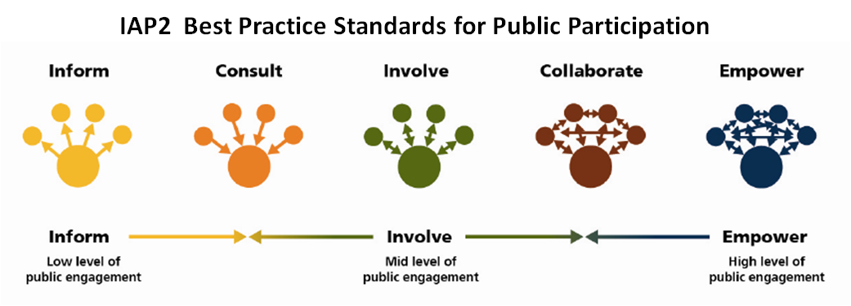
Developing a project-specific Public Participation process at the beginning of each project is a crucial first step in ensuring all participation efforts are efficient and effective. The successful implementation of the plan will help ensure the project reflects, to the greatest extent possible, what the community envisions. Public Participation can be thought of as a continuum of different strategies and techniques for different audiences and levels of participation required by the project. As described below the different levels of participation should be determined at the beginning of a project for what that projects’ goals are and what the needs of the audience in the community is.
Figure 1 Source: https://www.letstalkcramahe.ca/public-participation-spectrum

Inform. To provide the public with information on the project of decision. This does not actually provide the opportunity for public participation, but rather engages the public and provides the community with the information they need to understand the project and the decision-making process.
Consult. To obtain and consider public input at set points in the process. This is the basic minimum opportunity for public input, to consult simply means to ask. You are asking the public for their opinions and will consider the input received as decisions are made.
Involve. To work directly with the public and consider their input throughout the process. At this level, the public is invited into the process.
Collaborate. To engage the public in key activities and decisions during the process. The collaborative level includes the explicit attempt to find consensus solutions. In the end, the input received and will be used by those making decisions regarding the project.
Empower. To implement what the public decides. At the empower level, the public is provided with the opportunity to make decisions for themselves. The most common activity seen at this level are public voting or ballot measures.

Participation Plan Requirements
To ensure thorough stakeholder involvement, the project team must identify the key, stakeholders, partner agencies, interested parties, and impacted entities associated with a project. Below is a listing of typical project stakeholders to consider.
- Customized engagement strategies based on the project’s community and innovations in outreach.
- Early and continuous opportunities for involvement.
- Public meetings at convenient and accessible locations and times.
- Timely information on issues, processes, and procedures.
- Reasonable access to technical and policy information.
- Electronic accessible and available public information via the web.
- Adequate notice of involvement opportunities at key decision points.
- Methods for considering, responding to, and incorporating public input.
- A course of action for seeking out and considering the needs of the traditionally underserved.
- Periodic review, evaluation of the participation process, and adjusting strategies, when warranted, in a timely manner.

Federal Requirements
Valdosta On-Demand services receive 5307 Federal Transit Administration funds that help to keep the transit system viable. As such, there are federal public participation requirements that must be met such as having a written, locally developed process to solicit and consider public comment prior to raising a fare or implementing a major reduction in public transportation service, access to the Valdosta On-Demand website / print materials and property acquisition. This public participation plan will be used to inform and engage the public through various means of solicitation to encourage a robust public engagement process. Further, the City of Valdosta will consider and implement outreach initiatives that are noted in the adopted Valdosta-Lowndes Metropolitan Planning Organization’s Public Participation Plan.
In fact, as Valdosta On-Demand applies best practices, the goal is not only to adhere to federal regulations but increase the impact of these regulations to create an equitable and resilient public transit system. The regulations most relevant to Valdosta On-Demand services include:
- The Americans with Disabilities Act of 1990 (ADA)
- Title VI of the Civil Rights Act of 1964 and Other Nondiscrimination Laws
- Executive Order 12898 Actions to Address Environmental Justice in Minority Populations and Low-Income Populations
- National Environmental Policy Act (NEPA) of 1969
- Uniform Relocation Assistance and Real Property Acquisition Policies Act

What Are Typical Public Participation goals?

Stakeholder Involvement
The Public Participation Plan has set out to capture the spirit and the diverse values of the City of Valdosta through its stakeholder involvement program, which consists of three elements:
- The identification of the various stakeholders;
- The identification of participation techniques; and
- The schedule of completion for the VOD Public Participation Plan Update.
To accurately obtain the values and views of the City of Valdosta, a variety of outreach efforts will be made, including face-to-face conversations, visits, e-mail campaigns, website updates, social media updates, surveys, newspaper announcements and ride-a-longs.

Identification of Stakeholders
- City of Valdosta Council
- Valdosta Housing Authority
- Wiregrass Georgia Technical College
- United Way of Greater Valdosta
- City of Valdosta Neighborhood Development Department
- Miracle League of Valdosta

Stakeholder Involvement Summary:
All stakeholders were able to participate through a series of emailed surveys. The stakeholders responded to each question how they felt public involvement in public transit decision making would best serve the community. Each stakeholder was able to submit comments, questions and concerns via email.
Emailed stakeholder questions and responses:
- How should Valdosta On-Demand transit system gather public input?
- What are the most appropriate methods for gathering input from the public about the Valdosta On-Demand Service?
- Is there a specific geographic area or population in need that Valdosta On-Demand should concentrate on in order to obtain public input?

Stakeholders suggested conducting community or online surveys and meeting with neighborhood residents to gather their feedback and input on public transit issues. They also felt that Valdosta On-Demand needs to interact with the community through vendor tables at community events and being available to educate citizens about the public transit service. Another suggestion from stakeholders was the use of comment cards or a QR code so that riders could provide immediate feedback on the transit system using their phones. They noted that public forums or town halls are effective ways to listen to the concerns of residents in the Valdosta community.

Goals, Objectives, and Actions
It is well understood that successful public participation is a cornerstone of a successful project. It is particularly important and rewarding to bring community members into the individual project planning process because the resulting decisions often have a direct and palpable effect on their daily lives. With this in mind, and anchored by the City of Valdosta Mission Statement, Valdosta's On-Demand Public Participation Plan sets forth Goals, Objectives and Actions for robust engagement.

Three overarching goals support Valdosta On-Demand Public Participation efforts. They are:
- Widely disseminate, clear, complete, and timely information to the residents, stakeholders, affected agencies, and interested parties regarding the overall Valdosta On-Demand program.
- Create an open and ongoing two-way public involvement process that ensures comprehensive resident, stakeholder, agency, and interested party input into and full participation in plans, projects, and programs.
- Achieve early involvement and maintain continuous involvement of the public in the development of plans, projects, and programs.
The objectives and actions relating to each goal are listed below.
Goal 1. Widely disseminate, clear, complete, and timely information to the residents, stakeholders, affected agencies, and interested parties regarding the overall On-Demand program.
Objective 1: Valdosta On-Demand will identify organizations and individuals representing a broad spectrum of community interests and encourage their participation in the project.
Action 1: Valdosta On-Demand will make presentations at civic, municipal, county, and other stakeholder group meetings to provide pertinent information regarding its program of work.
Objective 2: Valdosta On-Demand will develop relationships and form partnerships with organizations in the communities and use these partnerships to develop a better understanding of Valdosta On-Demand services in the community.
Action 2: Valdosta On-Demand will participate in activities such as festivals, workshops, and summer camps conducted by partner organizations to provide pertinent information regarding its program of work.
Action 3: Valdosta On-Demand will distribute and make literature available at other agencies’ locations and events.
Objective 3: Coordinate public involvement activities with other similar programs to make best use of staff and resources while minimizing public time demands.
Action 1: Valdosta On-Demand will coordinate and, where possible, collaborate with the public involvement efforts of other departments and agencies, for projects located in the vicinity of Valdosta On-Demand services, particularly those focused on transportation.
Goal 2. Create an open and ongoing two-way public involvement process that ensures comprehensive resident, stakeholder, agency, and interested party input into and full participation in plans, projects, and programs.
Objective 1: Information will be disseminated through a variety of media.
Action 1: Valdosta On-Demand will develop communication tools using both traditional and social media and use visualization techniques including PowerPoint presentations, display boards, maps, interactive mapping, video, and the Valdosta website to assist in communicating general and project specific information with the public.
Action 2: Valdosta On-Demand will use its website and social media platforms to publish and make available to gather input and feedback from the public about transit services.
Action 3: Valdosta On-Demand will use its website and social media platforms to receive input from the community on the Agency’s programs, plans, and projects. Publish and make available plans and studies and to inform the public about opportunities to participate.
Goal 3. Achieve early involvement and maintain continuous involvement of the public in the development of plans, projects, and programs.
Objective 1: Public participation strategies will be tailored to fit the audience and the issues, rather than using a “one size fits all” approach.
Action 1: Valdosta On-Demand will strive to understand the interests and concerns of target audiences in order to determine the most relevant content and most effective ways to communicate with each segment.
Action 2: Valdosta On-Demand will target specific audiences, go where the people are, and create or participate in events targeted to those audiences.
Action 4: Valdosta On-Demand will develop a better understanding of appropriate communications strategies, content and format for all population segments, including those in disadvantaged communities (ex: low-literacy individuals and non-English speaking communities).
Objective 2: Valdosta On-Demand will seek to improve its community engagement program by regularly reviewing this plan and its outreach activities.
Action 1: Valdosta On-Demand will regularly survey the public on the best ways to provide information, increase engagement, and utilize public input, and will incorporate resulting recommendations into the Public Participation Plan.
Action 2: Valdosta On-Demand will periodically update this Public Participation Plan.

How do you know what public participation tools are effective?
The type of participation activity used is driven by the goals for the participation. The table below offers a method for Valdosta On-Demand to monitor the effectiveness of various participation tools for each participation goal.
Public Participation Plan Evaluation Matrix
Objectives | Tools Used | Evaluation Criteria | Result | Performance Target | Target Status | Notes
GOAL ONE: Widely disseminate clear, complete, and timely information to the residents, stakeholder, affected agencies, and interested parties regarding the overall Valdosta On-Demand program as well as the individual plans, projects and programs.
Objective 1: Identify organizations and individuals representing a broad spectrum of community interests and encourage their participation in the project.
Objective 2: Valdosta On-Demand will develop relationships and form partnerships with organizations in the communities and use these partnerships to develop a better understanding of Valdosta On-Demand projects in the community.
Objective 3: Coordinate public engagement activities with other similar programs to make best use of staff and resources while minimizing public time demand.
GOAL TWO: Create an open and ongoing two-way public engagement process that ensures comprehensive resident, stakeholder, agency, and interested party input into and full participation in projects.
Objective 1: Information will be disseminated through a variety of media.
Objective 2: Engagement methodology selected will successfully reach target audience.
GOAL THREE: Achieve early engagement and maintain continuous involvement of the public in the development and lifetime of projects.
Objective 1: Public engagement strategies will be tailored to fit the audience and the issues, rather than using a "one size fits all" approach.
Objective 2: Valdosta On-Demand will seek to improve its community engagement program by regularly reviewing this plan and its outreach approach

