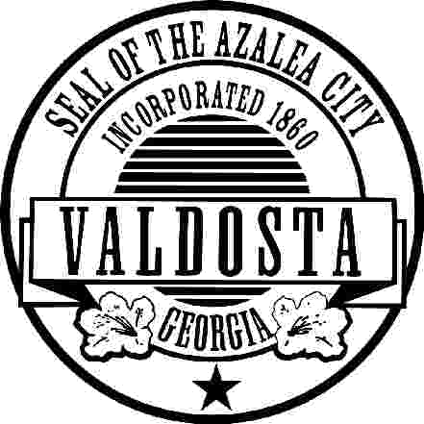
CITY OF VALDOSTA

OVERHEAD BANNER APPROVAL

ORGANIZATION:
TAX ID NUMBER:
CONTACT: |  |  |  |  |  |  | PHONE:
MAILING ADDRESS:
E-MAIL ADDRESS:
EVENT: |  |  |  |  |  | EVENT DATE:
EVENT LOCATION:
NUMBER OF BANNERS:
Hanging of banners over city streets is limited to the three locations listed below and subject to prior approval by the City Manager’s office. Banner approval is based on a first come, first serve basis and is limited to community-wide events organized by non-profit organizations. Banners can only be submitted six weeks in advance of event date.

Non-profit organizations and their events should meet the following criteria to have an overhead banner:
- Must submit a drawing or picture of printed banner(s)
- Banners are limited to approval for only one event per year for a maximum of two-weeks.
- No more than two banner locations will be approved; however, two locations may not be guaranteed when multiple requests are received for certain peak times i.e.) spring, fall, holidays.
- Events must be open to the general public, such as concerts, runs, fundraisers. An event shall mean a public function with a program, festival, bazaar, activity, etc.
- The advertised events must not be limited to, or exclusive of, a specific religious affiliation.
- Banners must be picked up within 2 weeks after the END DATE. We will no longer hold banners. They will be disposed of if they are not picked up.
**In order to cover the cost associated with required liability insurance, display and removal of the banner, organizations must pay a $90.00 non-refundable administration fee along with submitting an application to the Engineering Department. Please make checks payable to the City of Valdosta.

**********PLEASE GIVE THIS INFORMATION TO YOUR BANNER CONTRACTOR!!!!!!***********
Banners must meet the following criteria:
1) Must be 3 feet wide and no longer than 20 feet
2) Must have metal eyes on top and bottom no more than 2 feet apart. The end eyelets should be doubled only 2 inches apart on the thickest part of the banner folds
3) Must not have commercial advertisement or logos
4) Must have at least six (6) wind-flaps
5) Must have at least four-inch (4”) letters
6) Must be professionally made and no handwritten verbiage
7) All banners shall be printed on each side. Two banners attached to each other are not allowed.

*Please know that if a banner is not built to these specifications, the City reserves the right not to put up the banner.
Please direct questions to the City of Valdosta Engineering Department 229.259.3530

LOCATIONS: N. Patterson Street |  |  | Northside Drive |  |  |  | Oak Street at VSU
START DATE: |  |  |  | END DATE:

OFFICE USE ONLY |  | RECEIVED DATE: |  |  | CHECK NUMBER OR CASH REC’D
APPROVED: |  |  |  |  |  | DATE:
ORGANIZATION CONTACTED: |  |  |  |  | EMAIL TO:  crandall@valdostadity.com

